**The Centennial Education Program for Community Youth**

**High Point University**

**100th Anniversary Campaign**

Madison Phelps

Table of Contents

Executive Summary 3

ROSIE Elements 4

Press Release 6

Madison Phelps

Executive Summary

I am choosing to use HPU’s one million dollar budget to create an academic facility within the Nido & Mariana Qubein Children’s Museum, hire accredited teachers, faculty, and staff for the program, establish paid and unpaid internships and student opportunities for current students, and to utilize the country’s top public school curriculums within our “school.” The Centennial Education Program for Community Youth, or CEP, will open in August of 2024. The program will run as a functional charter or public school - it will be affordable to the community and useful to young learners. The program will run August-May, just as a normal academic year, and will involve normal school day hours, as well as extra “Life Skills” seminars, classes, and on-campus opportunities. This program will include a liberal arts education for elementary, middle, and high school aged learners. Core subjects, as well as extraordinary job-specific workshops will also be provided. High school aged students will also have the opportunity to participate in dual enrollment classes that will count for college credits. Education students from the Stout School of Education will have opportunities to student-teach and tutor within the CEP. The community, as well as alumni and donors, will be invited to school functions held at the Qubein Arena, as well as artistic productions and commencement ceremonies. High Point University will also establish a fountain dedicated to this program, where young students will visit at the beginning and the end of each school year, as well as their families and teachers. Graduating seniors will return to this fountain at their commencement ceremony to close the chapter of their education at the CEP. I feel as if this campaign will appeal to the emotions of the community members, alumni, and donors who see increasingly concerning statistics for schools and the community of High Point, NC. The community will feel seen and respected within the aspect of a larger university, and I feel as if letting them know that their children, grandchildren, and family are in good hands with the Centennial Education Program will build a higher level of trust and will bridge the gap between HPU’s pristine campus and the struggling community.

ROSIE PLAN

The Centennial Education Program for Community Youth

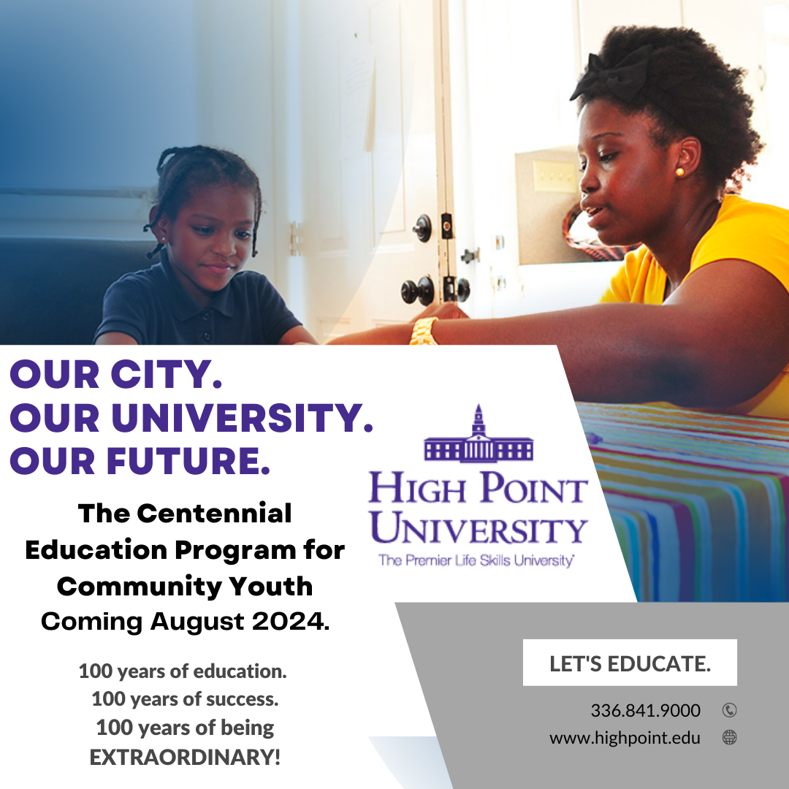

**Once In a Century Education!**

* Appeals to the community of High Point, NC - bringing high quality education to everyone.
* Utilizes the Nido & Mariana Qubein Children’s Museum as a learning environment for High Point’s youth.
* The Stout School of Education will provide student teachers as tutors, as well as top-notch professors and a holistic liberal arts curriculum.
* Advertisements will be presented on multiple channels, including social media, radio, television, and print.
* Social media graphics, print magazines and flyers, radio and news promotionals, and high-quality, newly produced film advertisements will be distributed.
* When cultivating my ideas for this campaign, I wanted to utilize an idea that would appeal to the community of High Point. While researching the success rates of the Guilford County Schools System, I found that average grades for core subjects are dropping below a C in elementary school. Lots of local families do not have the means to pay for supplemental tutoring, private education, or specialized teaching for their children. I feel as if parents of students who are struggling with their academic coursework will appreciate the University dedicating their 100th year of education outward to the young students of the city of High Point and beyond. I believe that this campaign embodies the motto, “Our city. Our university.” because it directly impacts the community and city on a long term scale.

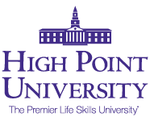

1 University Parkway  **FOR IMMEDIATE RELEASE 2-26-2023**

High Point, NC 27268

1-336-841-9000

mphelps@highpoint.edu

**Once In A Century Education**

The Centennial Education Program for Community Youth: Celebrates High Point University’s 100th Anniversary while educating the future of High Point University and beyond.

**High Point, NC:** High Point University has launched the Centennial Education Program for Community Youth - a brand new education program in collaboration with both undergraduate and graduate students and faculty within the Stout School of Education. The University will be providing elementary through middle education during the academic year to local youth at the Nido and Mariana Qubein Children’s Museum starting in August of 2024 to highlight 100 years of extraordinary education.

“We are extremely excited to announce this program to the High Point Community,” says Dr. Nido R. Qubein, President of High Point University. “Providing extraordinary academics and regular day schooling to families in need further highlights High Point University’s mission: to provide an extraordinary education in a loving environment with caring people. This is what our community needs.” Crissy Pratt, a Guilford County Schools District 2 Board Member, states, “The GCS System has a constant goal to bring our high school graduation rate up to 100%, and I believe that High point University’s Centennial Education Program for Community Youth will greatly aid us in achieving that goal.”

High Point University is a private university in High Point, North Carolina. It is affiliated with the United Methodist Church. The university was founded as High Point College in 1924, and it became High Point University in October 1991. High Point University is Your Premier Life Skills University. Founded in 1924, High Point University has grown tremendously, and is ranked #1 Most Innovative and Best Regional Colleges in the South by U.S. News.

###